Project Testing phase

**Tools used for Testing:**

* **React testing libraries**

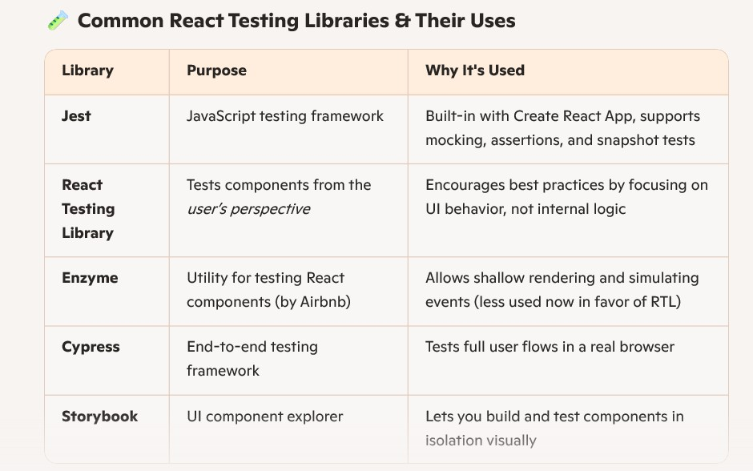

**Why use these tools?**

* Are well-supported and actively maintained
* Integrate smoothly with React and modern dev workflows
* Help catch bugs early and improve code quality
* Simulate real user behavior, not just internal logic
* **Npm testing libraries**

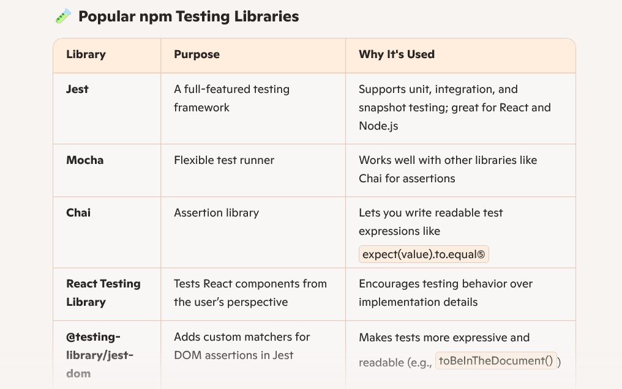

**Why use *these* tools?**

* Are **well-documented** and actively maintained
* Integrate easily with modern JavaScript frameworks
* Help catch bugs early and improve confidence in your code
* Support **different levels of testing**: unit, integration, and end-to-end